BANK LOAN REPORT QUERIES

SUMMARY
---1. Total Loan Applications
SELECT COUNT(id) AS Total_Applications FROM bank_loan_data;
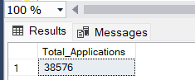

---2. Total Funded Amount
SELECT COUNT(id) AS Total_Applications FROM bank_loan_data
WHERE MONTH(issue_date) = 12;
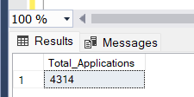

---3. PMTD Loan Applications
SELECT COUNT(id) AS Total_Applications FROM bank_loan_data
WHERE MONTH(issue_date) = 11;
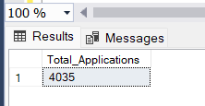

---4.Total Funded Amount
SELECT SUM(loan_amount) AS Total_Funded_Amount FROM bank_loan_data;
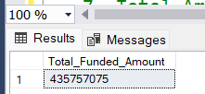

---5. Average Debt-to-Income Ratio (DTI)
SELECT SUM(loan_amount) AS Total_Funded_Amount FROM bank_loan_data
WHERE MONTH(issue_date) = 12;
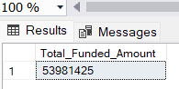

---6. PMTD Total Funded Amount
SELECT SUM(loan_amount) AS Total_Funded_Amount FROM bank_loan_data
WHERE MONTH(issue_date) = 11;
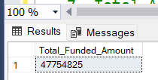

---7. Total Amount Received
SELECT SUM(total_payment) AS Total_Amount_Collected FROM bank_loan_data;
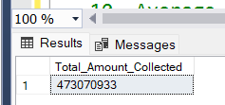

---8. MTD Total Amount Received
SELECT SUM(total_payment) AS Total_Amount_Collected FROM bank_loan_data
WHERE MONTH(issue_date) = 12;
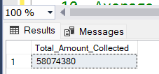

---9. PMTD Total Amount Received
SELECT SUM(total_payment) AS Total_Amount_Collected FROM bank_loan_data
WHERE MONTH(issue_date) = 11;
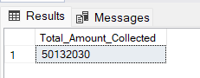

---10. Average Interest Rate
SELECT AVG(int_rate)*100 AS Avg_Int_Rate FROM bank_loan_data;
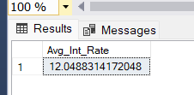

---11. MTD Average Interest
SELECT AVG(int_rate)*100 AS MTD_Avg_Int_Rate FROM bank_loan_data
WHERE MONTH(issue_date) = 12;
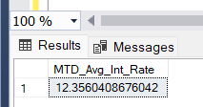

---12. PMTD Average Interest
SELECT AVG(int_rate)*100 AS PMTD_Avg_Int_Rate FROM bank_loan_data
WHERE MONTH(issue_date) = 11;
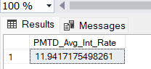

---13. Avg DTI
SELECT AVG(dti)*100 AS Avg_DTI FROM bank_loan_data;
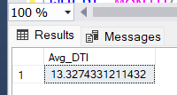

---14. MTD Avg DTI
SELECT AVG(dti)*100 AS MTD_Avg_DTI FROM bank_loan_data
WHERE MONTH(issue_date) = 12;
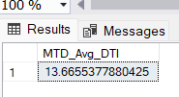

---15. PMTD Avg DTI
SELECT AVG(dti)*100 AS PMTD_Avg_DTI FROM bank_loan_data
WHERE MONTH(issue_date) = 11;
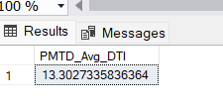

GOOD LOAN ISSUED
---16. Good Loan Percentage
SELECT
(COUNT(CASE WHEN loan_status = 'Fully Paid' OR loan_status = 'Current' THEN id END) * 100.0) /
COUNT(id) AS Good_Loan_Percentage
FROM bank_loan_data;
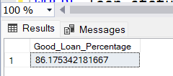

---17. Good Loan Applications
SELECT COUNT(id) AS Good_Loan_Applications FROM bank_loan_data
WHERE loan_status = 'Fully Paid' OR loan_status = 'Current';
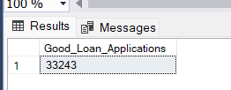

---18. Good Loan Funded Amount
SELECT SUM(loan_amount) AS Good_Loan_Funded_amount FROM bank_loan_data
WHERE loan_status = 'Fully Paid' OR loan_status = 'Current';
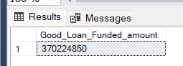

---19. Good Loan Amount Received
SELECT SUM(total_payment) AS Good_Loan_amount_received FROM bank_loan_data
WHERE loan_status = 'Fully Paid' OR loan_status = 'Current';
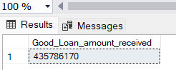

BAD LOAN ISSUED
---20. Bad Loan Percentage
SELECT
(COUNT(CASE WHEN loan_status = 'Charged Off' THEN id END) * 100.0) /
COUNT(id) AS Bad_Loan_Percentage
FROM bank_loan_data;
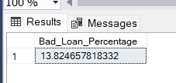

---21. Bad Loan Applications
SELECT COUNT(id) AS Bad_Loan_Applications FROM bank_loan_data
WHERE loan_status = 'Charged Off';
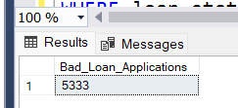

---22. Bad Loan Funded Amount
SELECT SUM(loan_amount) AS Bad_Loan_Funded_amount FROM bank_loan_data
WHERE loan_status = 'Charged Off';
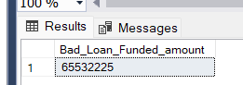

---23. Bad Loan Amount Received
SELECT SUM(total_payment) AS Bad_Loan_amount_received FROM bank_loan_data
WHERE loan_status = 'Charged Off'
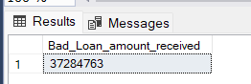

STATUS
---24. LOAN STATUS
SELECT
loan_status,
COUNT(id) AS LoanCount,
SUM(total_payment) AS Total_Amount_Received,
SUM(loan_amount) AS Total_Funded_Amount,
AVG(int_rate * 100) AS Interest_Rate,
AVG(dti * 100) AS DTI
FROM
bank_loan_data
GROUP BY
loan_status;
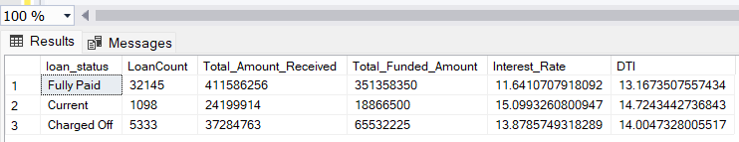

SELECT
loan_status,
SUM(total_payment) AS MTD_Total_Amount_Received,
SUM(loan_amount) AS MTD_Total_Funded_Amount
FROM bank_loan_data
WHERE MONTH(issue_date) = 12
GROUP BY loan_status;
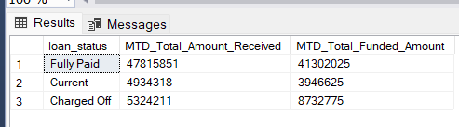

---25. MONTH
SELECT
MONTH(issue_date) AS Month_Munber,
DATENAME(MONTH, issue_date) AS Month_name,
COUNT(id) AS Total_Loan_Applications,
SUM(loan_amount) AS Total_Funded_Amount,
SUM(total_payment) AS Total_Amount_Received
FROM bank_loan_data
GROUP BY MONTH(issue_date), DATENAME(MONTH, issue_date)
ORDER BY MONTH(issue_date);

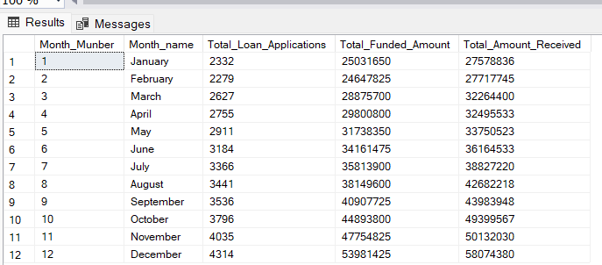

---26. STATE
SELECT
address_state AS State,
COUNT(id) AS Total_Loan_Applications,
SUM(loan_amount) AS Total_Funded_Amount,
SUM(total_payment) AS Total_Amount_Received
FROM bank_loan_data
GROUP BY address_state
ORDER BY address_state;
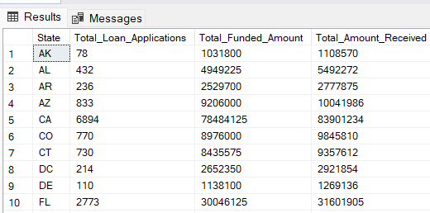

---27. TERM
SELECT
term AS Term,
COUNT(id) AS Total_Loan_Applications,
SUM(loan_amount) AS Total_Funded_Amount,
SUM(total_payment) AS Total_Amount_Received
FROM bank_loan_data
GROUP BY term
ORDER BY term;
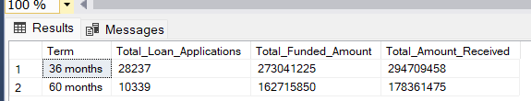

---28. EMPLOYEE LENGTH
SELECT
emp_length AS Employee_Length,
COUNT(id) AS Total_Loan_Applications,
SUM(loan_amount) AS Total_Funded_Amount,
SUM(total_payment) AS Total_Amount_Received
FROM bank_loan_data
GROUP BY emp_length
ORDER BY emp_length;
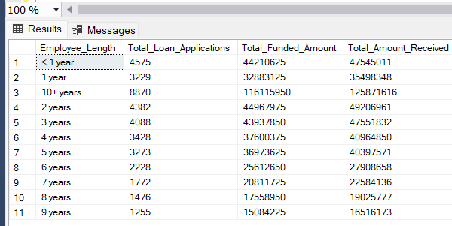

---29. PURPOSE
SELECT
purpose AS PURPOSE,
COUNT(id) AS Total_Loan_Applications,
SUM(loan_amount) AS Total_Funded_Amount,
SUM(total_payment) AS Total_Amount_Received
FROM bank_loan_data
GROUP BY purpose
ORDER BY purpose;

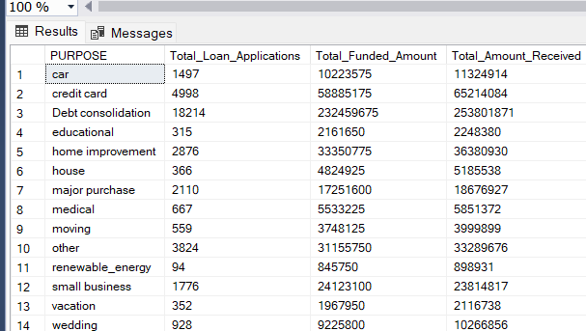

---30. HOME OWNERSHIP
SELECT
home_ownership AS Home_Ownership,
COUNT(id) AS Total_Loan_Applications,
SUM(loan_amount) AS Total_Funded_Amount,
SUM(total_payment) AS Total_Amount_Received
FROM bank_loan_data
GROUP BY home_ownership
ORDER BY home_ownership;
